Diagnostic Medical Sonography
Wallace Health Sciences - South
1480 Nashville Pike, Gallatin, Tennessee 37066
Phone 615-452-8600, Fax 615-230-3224

Evaluation of Observing Applicant
Updated: 10/30/2023

Applicant Name: ______________________________ Applicant Signature: ___________________________________

For the Applicant: Please have this form filled out by the ARDMS registered sonographer you observed with the most during your experience. By signing this form, you are authorizing the individual permission to complete an evaluation of you. This evaluation will become part of your program application and will remain confidential. Please provide an envelope for the sonographer to place this evaluation in when it is completed.

For the Evaluator: Thank you for allowing this prospective applicant the opportunity to observe in your imaging department. Your input is a valuable part of our selection process. Please place the completed form in the provided envelope and sign over the seal prior to returning it to the applicant.

Please rate the prospective applicant in the following areas using the defined grading scale:
4 = Superior, 3 = Good, 2 = Average, 1 = Poor, 0 = unacceptable
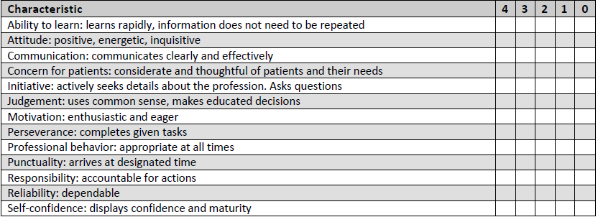

Indicate your overall recommendation of the prospective applicant:
( ) Strongly Recommend
( ) Recommend
( ) Recommend with Reservations
( ) Do Not Recommend

Sonographer Name ______________________________ Sonographer Signature _______________________________

ARDMS # ____________

Facility Name _______________________________________________________
Department Phone Number ________________________________

